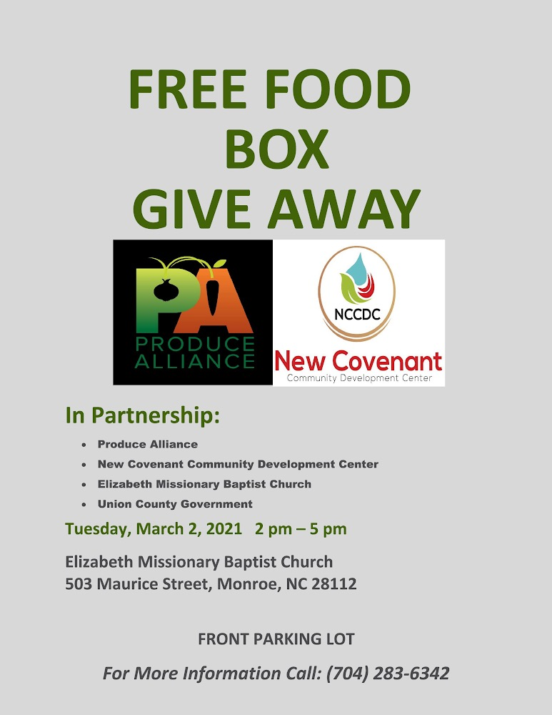

Approximately 1,100 boxes of food will be given to Union County families in need each Tuesday, starting March 2 through March 23, at Elizabeth Missionary Baptist Church. The total of 4,400 food boxes have been generously donated by Produce Alliance and will be distributed by Elizabeth Missionary Baptist Church in the church parking lot (503 Maurice Street, Monroe) for the next four Tuesdays between 2:00 p.m. and 5:00 p.m.

Union County is proud to assist with the distribution effort.  
Any individual or family in need is welcome to drive-through and receive a box(es) of food which includes dairy products, fresh produce, and precooked protein. No advance registration is necessary.

Additionally, Resourceful Clinical Laboratories will be at the church in the rear parking lot offering free drive-thru testing for COVID-19 on March 2.

For more information call 704-283-6342.

